**HIVE**

create table Cinema(movie_id int, movie_name VARCHAR(30), yol int, rating float, duration int) row format delimited fields terminated by ',' ;  
  
load data local inpath '/home/akshay/Desktop/movies.txt' into table Cinema;  
  
select * from Cinema;  
  
Queries-  
  
A)select count(movie_name) from Cinema where yol>=1950 and yol<=1960;



B)select count(movie_name) from Cinema where rating>4;

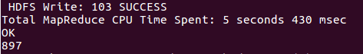

C)select movie_name from Cinema where rating between 3 and 4;

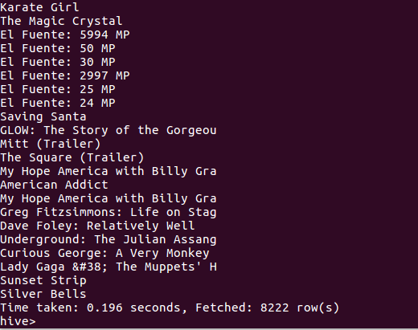

D)select count(movie_name) from Cinema where duration >7200;

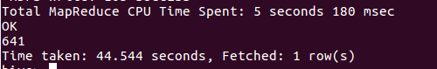

E)select yol,count(movie_name) from Cinema group by yol;

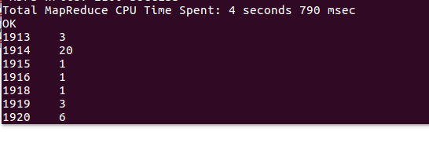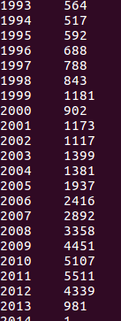

F)select count(movie_name) from Cinema;

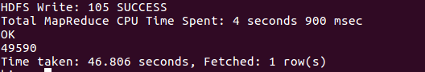

PIG

Cinema = load '/w3/movies.txt' USING PigStorage(',') as (movie_id:int, movie_name:chararray, yol:int, rating:double, duration:int);  
  
describe Cinema;  
  
illustrate Cinema;

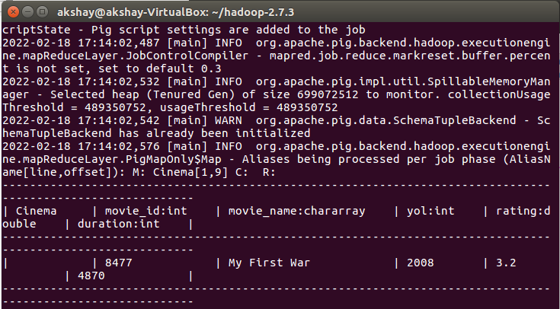  
  
A)  
A1 = filter Cinema by yol>=1950 and yol<=1960;  
A2 = group A1 all;  
A3 = foreach A2 generate COUNT (A1);  
dump A3;



B)  
B1 = filter Cinema by rating >4;  
B2 = group B1 all;  
B3 = foreach B2 generate COUNT(B1);  
dump B3;

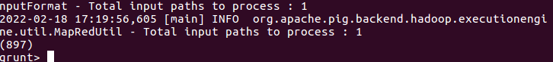

C)  
C1 = filter Cinema by rating > 3 and 4<rating;  
C2 = foreach C1 generate movie_name;  
dump C2;

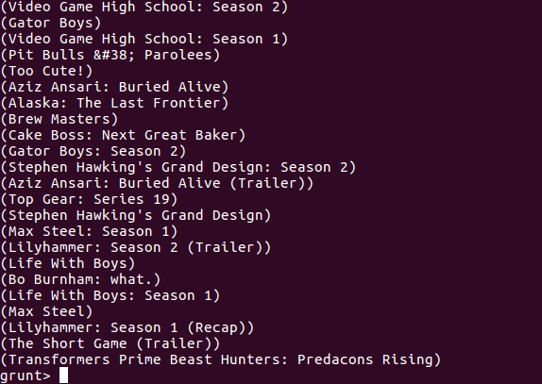

D)  
D1 = filter Cinema by duration>7200;  
D2 = group D1 all;  
D3 = foreach D2 generate COUNT(D1);  
dump D3;



E)  
E1 = foreach Cinema generate yol;  
E2 = group E1 by yol;  
E3 = foreach E2 generate group, COUNT(E1) as Movies;  
dump E3;

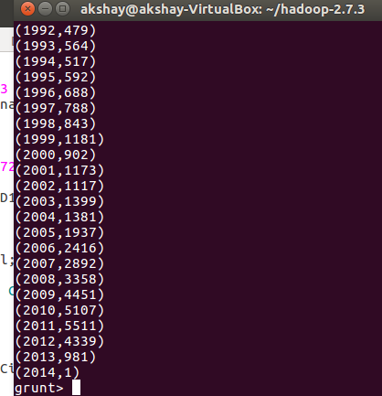  
  
F)   
F1 = group Cinema all;  
F2 = foreach F1 generate COUNT(Cinema);  
dump F2;

